**ST.ANNE’S**

**COLLEGE OF ENGINEERING AND TECHNOLOGY**

(Approved by AICTE, New Delhi. Affiliated to Anna University, Chennai)

(An ISO 9001: 2015 Certified Institution)

ANGUCHETTYPALAYAM, PANRUTI – 607 106.

**DEPARTMENT OF MECHANICAL ENGINEERING**

**ME6603 FINITE ELEMENT ANALYSIS**

**QUESTION BANK**

**UNIT-1 INTRODUCTION**

**PART-A**

1.What are initial and boundary value problems? [NOV10,12]

### 2. Classify Boundary conditions. [MAY14, NOV11]

### 3. What are the methods of solving Eigen value problems?[ MJ12]

### 4.List the various methods of solving boundary value problems. [MAY10]

### 5.What is the limitations of using a finite difference method? [MAY10]

6.What are the basic approaches to improve a finite element model? (Or)What are the various methods to solve the engineering problems? [NOV10]

### 7.What are the variational methods? [NOV10]

### 8..State the principle of minimum potential energy. (Or)

### [What is the stationary property of total potential energy?] [NOV07, 10, 13 MAY12,16]

### 9.What is Rayleigh-Ritz method? MJ14, ND15, MJ13, ND11, ND15

### 10.Mention the basic steps of Rayleigh Ritz method. [MAY12]

### 11.What is meant by weak formulation? [MAY13,15 NOV12]

### 12.Distinguish between the Rayleigh Ritz method and Finite Element Method. [NOV12,13,14]

13.What do you understand by the term “piecewise continuous function”? [NOV13]

### 14.What is Galerkin’s method of approximation? (Or) What is a weighted residual method? [ MAY12,14,16 NOV07,10 ]

### 15Mention the basic steps involved in weighted residual method. (Or) Mention the basic steps of Galerkin method. [ MAY13, NOV14, 13]

### 16.What is meant by nodes in finite element? [MAY14, NOV15,16]

### 17.List the types of nodes. (Or)What is meant by Primary and Secondary node? [MAY12,13]

### 18.Why polynomial types of interpolation functions are preferred over trigonometric functions? (Or) Why are polynomial terms preferred for shape functions in Finite

[NOV07,11,16 MAY11,13,14,15,17]

### 19.List the methods of finite element analysis. (Or)

What are the methods generally associated with the finite element analysis?MAY12,16]

### 20.What is meant by Post Processing*?[ MAY13, NOV14, 16]*

### 22.Distinguish between essential boundary conditions and natural boundary conditions. [ MAY14,NOV09]

### 22.What are ‘h’ and ‘p’ versions of finite element method?[Nov18]

### PART-B

1. The following differential equation is available for a physical phenomenon,

d2y/dx2 – 10x2 =5, 0≤x≤1 with boundary conditions as y (0) = 0 and y (1)= 0.

Find an approximate solution of the above differential equation by using Galerkin’s method of weighted residuals an also compare with exact solution.[MAY16]

2. Explain the step by step procedure of FEA.[MAY18 **2014&2012]**

3.(i)Enumerate the advantages & disadvantages of FEM. (ii)Discuss the factors to be considered in discretization of a domain.

4.Explain the process of discretization of a structure in finite element method in detail,

with suitable illustration for each aspect being and discussed.

5.A uniform rod subjected to a uniform axial load is illustrated in figure, the deformation of the bar is governed by the differential equation given below. Determine thedisplacement by applying Weighted Residual Method (WRM). [MAY18]

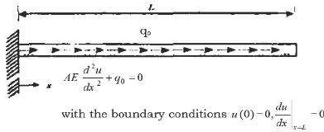

.6. A beam AB of span ‘l’ simply supported at the ends and carrying a concentrated load ‘W’ at the centre ‘C’ as shown in figure .Determine the deflection at the mid span by using . Rayleigh-Ritz method and compare with exact solution [MAY16,DEC16]

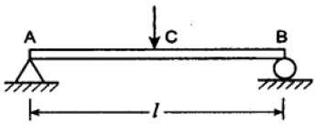.

7.Solve the differential equation for a physical problem expressed as d2y/dx2 + 100 = 0, 0≤x≤10 with boundary conditions as y(0)=0 and y(10)=0 using (i) Point collocation method (ii) Sub domain collocation method (iii) Least square method and (iv) Galerkin method.

8. Solve the differential equation for a physical problem expressed as d2y/dx2 + 50 = 0, 0≤x≤10 with boundary conditions as y (0) = 0 and y (10) = 0 using the trial function y= a1x (10-x) find the value of the parameters a1 by the following methods listed below.(i) Point collocation method

### (ii) Sub domain collocation method (iii) Least squares method and (iv) Galerkin method. .[MAY17]

### PART-C

1.A simple supported beam subjected to uniformly distributed load over entire span and it is subjected to a point load at the centre of the span. Calculate the deflection using

Rayleigh-Ritz method and compare with exact solutions. [MAY17,16 (Dec2015,May2013,Dec2007,Dec2008)]

### 2.Solve the ordinary differential equation d2y/dx2 + 10 x2 = 0, 0≤x≤1 with boundary conditions as

### y (0) = 0 and y (1) = 0 using the Galerkin’s method with the trial function No(x) = 0; N1(x) = x (1-x2). .[MAY16]

3.Derive the governing equation for a tapered rod fixed at one end and subjected to its own self weight and a force P at the other end as shown in fig. Let the length of the bar be 1 and let the cross section vary linearly from A1 at the top fixed end to A2 at the free end E and represent young modulus and specific weight of the material of the bar. Convert this equation in to its weak form and hence determine the matrices for solving the ritz technique? (APR/MAY 2015)

### 

### ******************

#### UNIT II – ONE DIMENSIONAL PROBLEMS

**PART-A**

1. Mention any two advantages of quadratic spar element over linear spar element? (Or) What is the use of introducing the quadratic shape functions? [MAY11,NOV12,13]

2. State the properties of Stiffness matrix. (Or)List out the stiffness matrix properties. [MAY12,10,14 15, NOV09, 10,11]

### 3. What are the types of problems treated as one dimensional problem? [MAY13]

### 4. State the properties of shape functions.(Or)State the significance of shape function.[ MAY10,13, 14,15 NOV14,15,12]

### 5. Determine any one linear shapes function and illustrate the same. (Or) Write the shape functions for a1D, 2noded element. (Or) Write the shape function for 1D linear bar element. [MAY13, NOV08]

### 6. Write the stiffness matrix for a 1D two noded linear element [NOV12,13]

### 7. Obtain the shape functions for a 1D quadratic spar element [MAY15, 16, NOV13]

8. Distinguish between 1D bar element and 1D beam element. [NOV09]

### 9. Plot the variations of shape function for 1-D beam element. [NOV10]

### 10. What is a truss? [MAY14]

### 11. State the assumptions made while finding the force in a truss. [NOV11].

### 12.Specify the expression for stiffness matrix for a truss element having four degrees of freedom. [MAY13,NOV15, MAY11, MAY15]

### 13. State Fourier’s Law of heat conduction used in FEA. MJ12

### 14. Mention two natural boundary conditions as applied to thermal problems. (OR)What are the boundary conditions in FEA heat transfer problem? [MAY16,11 DEC15]

### 15. Derive the convection and conduction matrix for a 1D linear bar element.[ MAY15]

### What is meant by longitudinal vibration and transverse vibration? [MAY14, 16 NOV15,18]

### 17. What are consistent and lumped mass techniques? NOV13

18. Specify the mass matrix for a 1D linear bar element. [MAY15, NOV11]

19. Consistent mass matrix gives accurate results than lumped mass matrix in dynamic analysis of bar element- Justify. [MAY16, NOV12]

20. Write down the expression of governing equation for free axial vibration of rod. [MAY16, 15]

**PART-B**

1.Determine the maximum deflection and slope in the beam, loaded as shown in fig. determine also the reactions at the supports E=200Gpa, I=20X10-6 m4, q=5kN/m and l=1m. **(APR/MAY2015)** 

2. Develop the Shape function, Stiffness matrix and force vector for one dimensional linear element. (M2015)

3. Consider a bar as shown in fig. Young’s Modulus E= 2 x 105 N/mm2. A1 = 2cm2,

A2 = 1cm2 and force of 100N. Calculate the nodal displacement. (NOV2016,MAY18)

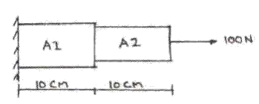

4. For the two bar truss shown in figure, determine the displacements of node 1 and the stress in

element 1-3 (May/June 2014,2016,2018, NOV2016)



5.Consider the bar shown in figure Axial force P =30 KN is applied as shown. Determine the nodal displacement, stresses in each element and reaction forces. **(Nov/ Dec 2009)**

#### 

6.A composite wall consists of three materials as shown in fig.the inside wall temperature is 200°C and the outside air temperature is 50°C with a convection coefficient of 10 W/cm 2 °C.Determine the temperature along the composite wall. (APR/MAY 2015,2018)

#### 

### PART-C

|  |  |  |
| --- | --- | --- |
| 1 | Derive the stiffness matrix for 2D truss element. | (Nov/ Dec 2015) |
| 2. | A steel bar of length 800mm is subjected to an axial load of 3kN.Find the elongation of the bar, | |
|  | neglecting self-weight. | (Nov/ Dec 2015) |

3.Establish the shape functional of an eight node quadrilateral element and represent them graphically (APR/MAY 2011)

4.Determine the first two natural frequencies of longitudinal vibration of the bar shown in fig.

assuming that the bar is discretized into two elements as shown E and ρ represent the Young’s modulus and mass density of the material of the bar. (APR/MAY 2015, 18)

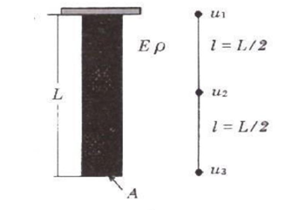

#### UNIT III – TWO DIMENSIONAL SCALAR VARIABLE PROBLEM

**PART-A**

1. What are the differences between 2D scalar variable and vector variable problems?[MAY12,15]

2. How do you define two dimensional elements? MAY14

### 3. Differentiate CST and LST elements.[DEC07,09,15,16,18 MAY08, 13]

4. Explain the important properties of CST element. [NOV08]

### 5. Differentiate: Local coordinate and Global coordinate. [MAY0813, NOV11]

### 6. What are the advantages of natural coordinates over global coordinates? [NOV08,07,14]

### 7. Define natural coordinate system. [NOV12,14]

### 8. What are the four basic sets of elasticity equations? [MAY12]

### 9. What do you meant by constitutive law? [NOV07,08 MAY17]

### 10. What is plane strain condition? [MAY15, NOV11,15]

### 11. Define plane stress problem with a suitable example. [MAY15, 13, NOV11, 16]

### 12. Distinguish between plane stress and plane strain problems. [NOV09,10,13,14 ,15MAY14,12]

### 13. Give one practical application where plane stress and plane strain problems can be applied. [MAY15, 16, 08, NOV08]

### 14. Write down the stress-strain relationship matrix for plane stress and plane strain condition. [NOV10,MAY17]

### 15. Why a 3 noded triangular element is called a constant strain triangular element?[MAY15, NOV14,10]

### 16. Obtain the shape functions for CST element.[MAY15]

17. Why are higher order elements required for FE analysis? .[MAY12,11]

### 18. What is QST (Quadratic Strain Triangle) element? [MAY14,17]

19. State the assumptions in the theory of pure torsion. [NOV16]

**PART-B**

1. 1. Determine the shape functions N1,N2, at the interior point p for the triangular element shown in the figure. (MAY/JUNE 2014

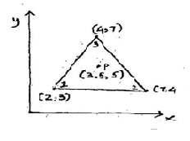

1. Compute the temperature at the point whose coordinates are(2.5,2.5). Also determine the 80°C isotherm. (APR/MAY 2015)

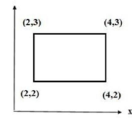

1. 3. Determine the shape function for a constant strain triangular (CST) elements in terms of natural co- ordinate system. (MAY/JUNE 2014& DEC2007&May2016)
2. Determine the stiffness matrix for the triangular elements with the (x,y) coordinate of the nodes are (0,4),(8,0) and (0,4) at nodes i,j,k Assume plane stress condition E = 200 Gpa, poisson’s ratio = 0.35? (Nov/ Dec2014)
3. Calculate element stiffness matrix and temperature force vector for the plane stress element shown. The total experiences a 200C increase the temperature. Assume coefficient of thermal expansion 6x10-6C of take E = 2x105 N/mm2, v =0.25, Thickness = 5mm. **(May2016,17)**

|  |  |
| --- | --- |
|  |  |

1. Develop the shape function derivation for a two-dimensional quadratic element.

7.For a 4-noded rectangular element shown in fig. Estimate the temperature point (7, 4). The nodal values of the temperatures are T1 = 42˚C, T2 = 54˚C and T3 = 56˚C

and T4 = 46˚C. Also determine 3 point on the 50˚C contour line.

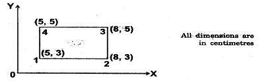

### PART-C

1.A 3 noded triangular element as shown in fig Calculate the temperature at the point P (4, 3), given that the temperatures at nodes 1, 2 and 3 are 75˚C, 90˚C and 60˚C respectively.

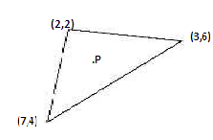

2. Find the temperature at point (1, 1.5) inside a triangular element shown with nodal temperature given as Ti = 40˚C, Tj = 34˚C and Tk = 46˚C. Also calculate the locationof the 42˚C contour line for triangular element shown in fig.

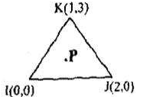

3. Derive the shape function for eight noded triangular element. (DEC16)

#### UNIT-IV TWO DIMENSIONAL VECTOR VARIABLE PROBLEM

**PART-A**

1. What is meant by axisymmetric field problem? Give an example. [NOV07, 09]
2. When are axisymmetric elements preferred? (Or)List the required conditions for a problem assumed to be axisymmetric. [NOV13,MAY10,14]
3. State the practical applications of axisymmetric elements.[MAY11,12,13,16, NOV10,14]

### 4. Write down the matrix formation of axisymmetric problem. (Or) Write the basic equation for axi- symmetric formulation. [MAY15,NOV12]

### 5. Give the constitutive law for axisymmetric problems.[MAY08,NOV10]

### 6. What are the ways by which a 3D problem can be reduced to a 2D problem? [NOV14,MAY17]

### 7. Write down the stress-strain relationship matrix for an axisymmetric triangular element. [MAY16]

### 8. Write down the strain-displacement relationship matrix for an axisymmetric triangular element.[MAY13,18]

### 9. Sketch a finite element model for a long cylinder subjected to an internal pressure using axisymmetric elements. [NOV13,15]

10. Name the strain available in axisymmetric triangular element. [MAY10]

11. Write down the stiffness matrix equation for an axisymmetric triangular element. [NOV10]

### 12. What do you meant by Shell element? State its advantages.[MAY16]

### 13. What are the types of shell elements? [MAY18]

14. Sketch an axisymmetric finite element model representing a rotating flywheel. [MAY13]

15. What do you meant by Plate element? [may18]

16. What are the ways in which a three dimensional problem can be reduced to a two dimension approach?[MAY17]

### 17. What are the types of non-linearity? [NOV07, MAY12]

### 18. What is geometric Isotropy? (Or Spatial Isotropy Or Geometric invariance)* [MAY13,15]

### 19. Write down the displacement matrix equation for an axisymmetric triangular element.

**PART-B**

1. Develop shape function and Stress-Strain relationship matrix for axisymmetric triangular elements. (Dec2008)

2.Develop Stress-Strain relationship matrix for axisymmetric triangular element.(Dec2007)

3.Calculate the stiffness matrix for the axisymmetric element shown in fig E= 2.1 x 106

N/mm2 and Poisson’s ratio as 0.3. [NOV16,MAY18]

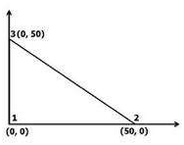

4.Calculate the element strains for an axisymmetric triangular element shown in fig the nodal displacement are. u1= 0.001, u2 = 0.002, u3 = -0.003, w1 = 0.002, w2 = 0.001 and w3 = 0.004 all dimensions are in mm.

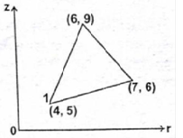

5.The nodal coordinates for an axisymmetric triangular element shown in fig are givenbelow. Calculate the strain-displacement matrix for that element. **(May2016,18)**

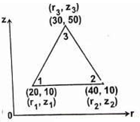

6.Determine the stiffness matrix for the axisymmetric element shown in fig take E as 2.1 x 106 N/mm2 and Poisson’s ratio as 0.3 . All dimensions are in mm. **(MAY17)**

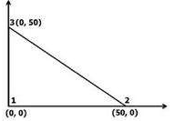

**PART-C**

1.Explain the plate and shell elements used in FEA.

2.A long hollow cylinder of inside diameter 100mm and outside diameter 120mm is firmly fitted in a hole of another rigid cylinder over its full length as shown in fig. The cylinder is then subjected to an internal pressure of 2 MPa. By using two element on the 10mm length shown calculate the displacements at the inner radius tame E =210 GPa. μ = 0.3

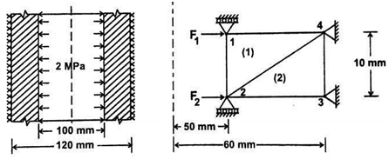

#### UNIT-V ISOPARAMETRIC FORMULATION

**PART-A**

1. What is the salient feature of an iso-parametric element? Give examples.[ Nov07, 13, 15, May12]
2. Define iso-parametric elements. [NOV08,14,18]

### 3.What is the purpose of isoparametric elements? [MAY13,16 NOV16]

### 4. Distinguish between sub-parametric and super-parametric elements. Give an example. [MAY15, NOV10,13]

### 5. Write down the stiffness matrix equation for four noded isoparametric quadrilateral elements. [MAY14,17]

### 6. What is the difference between natural coordinates and local coordinates? [MAY16]

7. Write the shape function for a 1D quadratic isoparametric element. [NOV14]

### 8. When do we resort to numerical integration in 2D elements? [NOV13]

### 9. What are Serendipity elements? [MAY15, NOV11,18]

### 10. What is meant by Gaussian elimination? [MAY13,15 NOV12,15]

### 11. Show that the matrix 𝑨= $\begin{matrix}COSθ & SINθ \\ -SINθ & COSθ\end{matrix}$ is orthogonal. [MAY14]

12. List any two sources of errors in finite element method. [NOV15,10]

13. Define mesh refinement. MAY15

### 14. Define dynamic analysis. Give examples. [MAY14,18 NOV11,15,16]

### 15. Define normal modes. [MAY15,13]

16. What is the principle of mode superposition technique? [MAY13, NOV13]

# 17. What is the difference between static and dynamic analysis? MAY2000

18. Give the Lagrange equation of motion. [MAY12,16 NOV15,16]

### 19. What are the advantages of Gauss quadrature numerical integration for isoparametric elements? [NOV16, 13]

**PART-B**

1.Develop the shape functions for a four-noded rectangular element by using natural co-ordinate system. **(May2016)**

2.For the isoparametric 4 noded quadrilateral element Calculate the Cartesian coordinates of the point P which has local coordinates ε = 0.5 and η = 0.5 as shown in figure.[NOV2007]

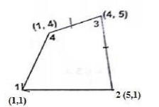

3. Calculate the Cartesian coordinates of the point P which has local coordinates ε = 0.8 and η = 0.6 as shown in figure. Also evaluate the Jacobian matrix. **(May2016,17)**

|  |
| --- |
|  |

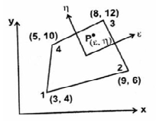

4.Evaluate the Jacobian matrix at the local coordinates ε=η= 0.5 for the isoparametric quadrilateral element with its global coordinates as shown in fig. Also evaluate the strain-displacement matrix. **(Dec2009,16**)

|  |  |
| --- | --- |
| . |  |

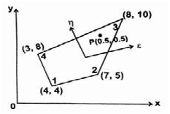

5.Find the integral  using Gaussian quadrature method with 2 point scheme. The Gauss points are ±0.5774 and the weight at the two points are equal to unity.[MAY2018].

6. Evaluate the integral $\int_{-1}^{1}{\left(x4+3x3-x\right)dx}$ using Gaussian quadrature method.

**PART-C**

1.For a four noded rectangular element shown in fig Calculate the following (a). Jacobian matrix (b). StrainDisplacement matrix (c). Element strain and d. Element stress.[MAY2018,16]

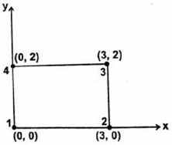

2.For the element shown in fig. Calculate the Jacobian matrix. Also evaluate the strain-displacement matrix.[MAY18]

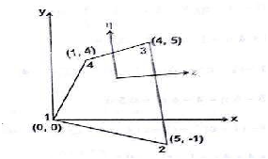

|  |  |
| --- | --- |
| 3.Determine the shape function for a constant strain triangular (CST) elements terms of natural co-ordinate system. [MAY/JUNE 2014& DEC2007] |  |

**************************************************

.

|  |  |  |
| --- | --- | --- |
|  |  |  |